  - Upcoming Dates:
Kenbrook Road, Hucknall, Nottingham NG15 8HY
Tel: 0115 9638845 Fax: 9638176
E-mail: office@beardallfields.org.uk
Website: www.beardallfields.org.uk

Upcoming dates:
- School Sponsored Run – week beginning 22nd January
- Y3 Nottingham Castle Trip
- NSPCC Rocks Day – Friday 2nd February

  - Careers Talks
We are in the processing of arranging some career talks for the children to increasing their awareness, broaden their horizons and inspire them for the future. If you, or someone you know, are interested in talking to the children about your career (past or present) we would love to hear from you. Please contact Mr. Drayton via ClassDojo or sdrayton@beardallfields.org.uk for more information.

  - Upcoming Sponsored Land’s End to John O’Groats Run
As part of our continued fundraising for school playground equipment, Beardall Fields PTA have organised a sponsored school run. We will be collectively running the distance from Land’s End to John O’Groats – a distance of 1,084 miles. Each lap the children complete will contribute to our school total. As seven laps of the coloured footprints around the playground equals one mile, this means as a school we will be completing 7,588 laps. All children will be encouraged to complete as much as they can but with what they are comfortable doing. Should we be successful each child will receive a certificate of completion and will also receive a school medal for completion.
The letter, with sponsorship form, will be sent out to children next week but is attached on the next page for your information at this point.
  - Parents’ Evening Survey
We would like your views on our parents’ evening online booking system. Please complete our short survey to give us your feedback https://shorturl.at/gIQV7
  - Parking
The parking outside of school is causing real concern. Please do not park on the yellow lines as we need to ensure all of our children are safe leaving school. Please be aware Civil Enforcement Officers regularly patrol our area.
  - NSPCC Rocks Day
As part of NSPCC Number Day 2024, we are excited to announce that we will be holding our FIRST EVER Beardall Rock Star Day. This will take place on Friday 2nd February. Alongside this, we will be taking part in the TTRS Rocks competition, as well as holding an internal school competition for the entire week commencing 29th January.
We encourage the children to come to school dressed as ‘rock stars’ on Friday 2nd February - we will be accepting voluntary £1 contributions for the NSPCC charity. This does not need to be an expensive undertaking (face paint, tie around the head, inflatable instrument etc.). There will be prizes for the most inventive costumes and certificates for the TTRS competition winners.
We look forward to ‘rocking out’ with you!
Mr Sellers


Sponsored School Run: Land’s End to John O’Groats


As part of our continued fundraising for school playground equipment, Beardall Fields PTA have organised a sponsored school run. We will be collectively running the distance from Land’s End to John O’Groats – a distance of 1,084 miles. Each lap the children complete will contribute to our school total. As seven laps of the coloured footprints around the playground equals one mile, this means as a school we will be completing 7,588 laps. All children will be encouraged to complete as much as they can but with what they are comfortable doing. Should we be successful each child will receive a certificate of completion and will also receive a school medal for completion.
The event will take place during the school week of 22nd January. Updates on our progress will be given daily. We ask that all sponsorship money is to be returned to school before Friday 2nd February.
The aim of running a mile (or more) is to improve the physical health and wellbeing of our children, to promote positive healthy lifestyles and to inspire them to challenge themselves to become more active throughout the school day.
Please find attached sponsorship form where you can sponsor a total amount or an amount per mile. We envisage our younger children completing a mile and our older children completing between 1-3 miles. All money raised will be put towards prospective playground equipment (see pictures below) so please ask family and friends to give generously! 😊
Prospective Playground Equipment
There are a number of different pieces of equipment we are fundraising towards for all children to use here at Beardall Fields. Our sponsored run and future PTA events will go towards these projects.
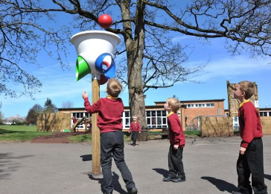
Additional shooting games
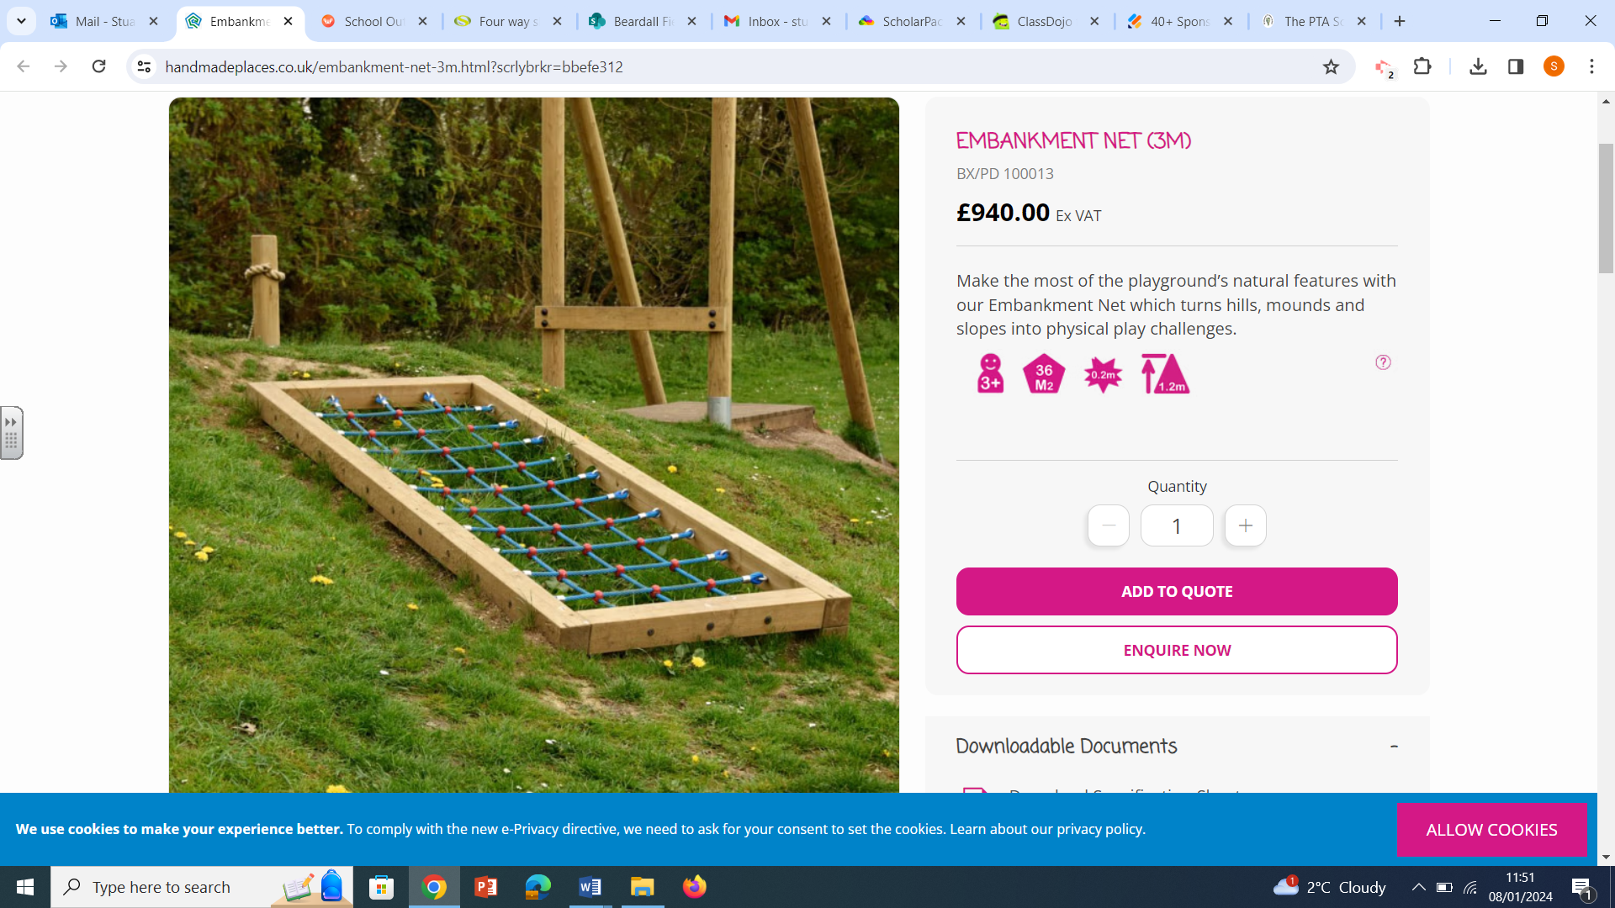
Embankment nets and ramps
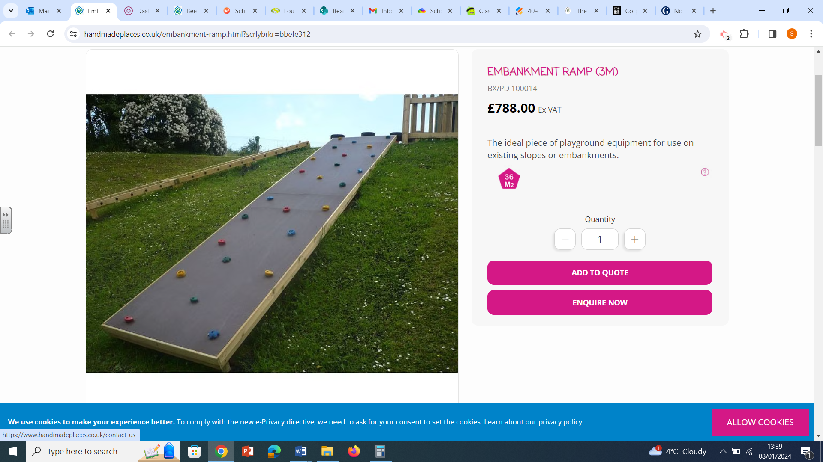
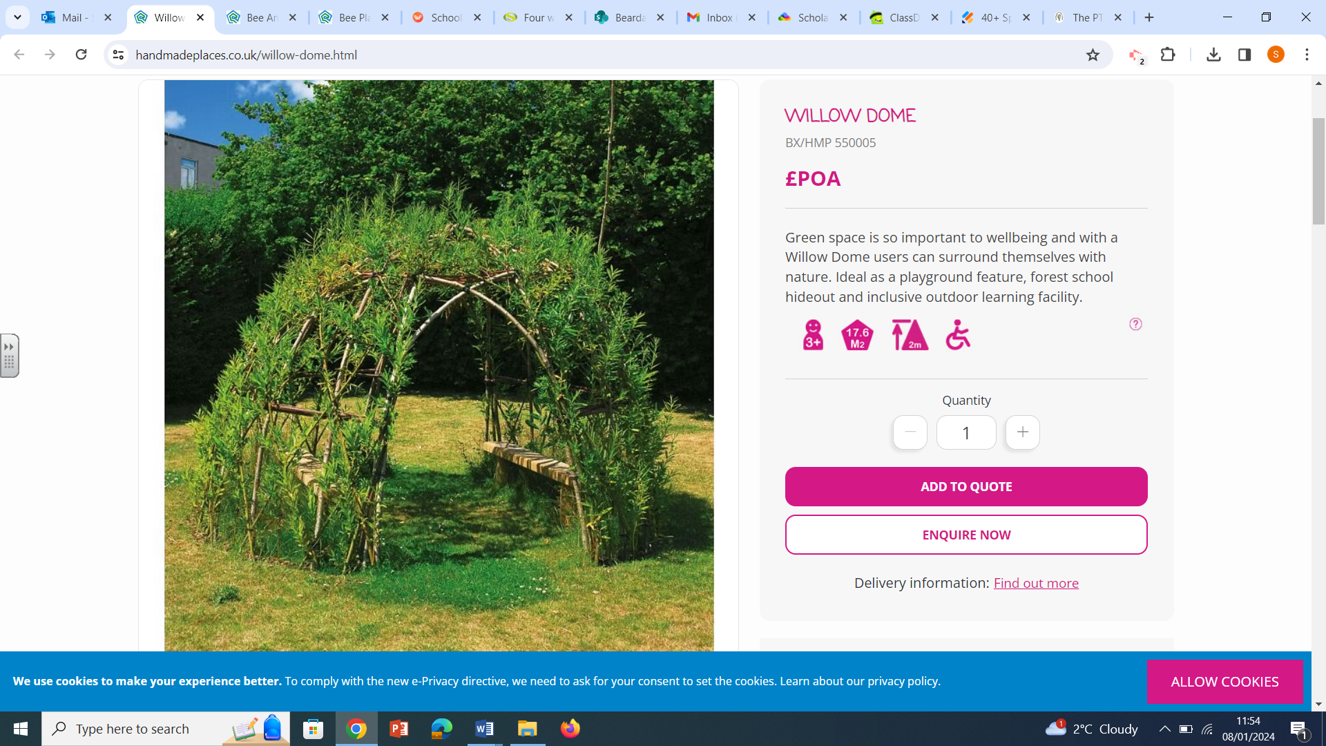
Allotment trail, shade and creative seating
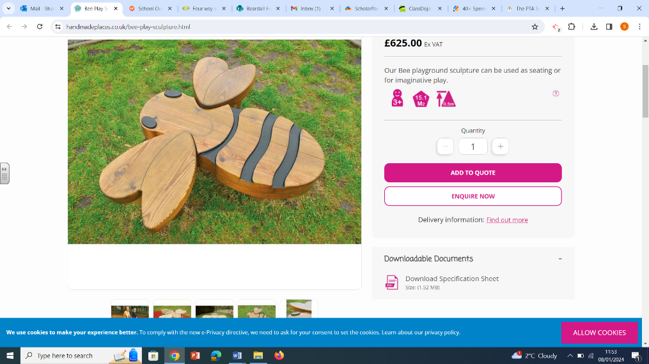
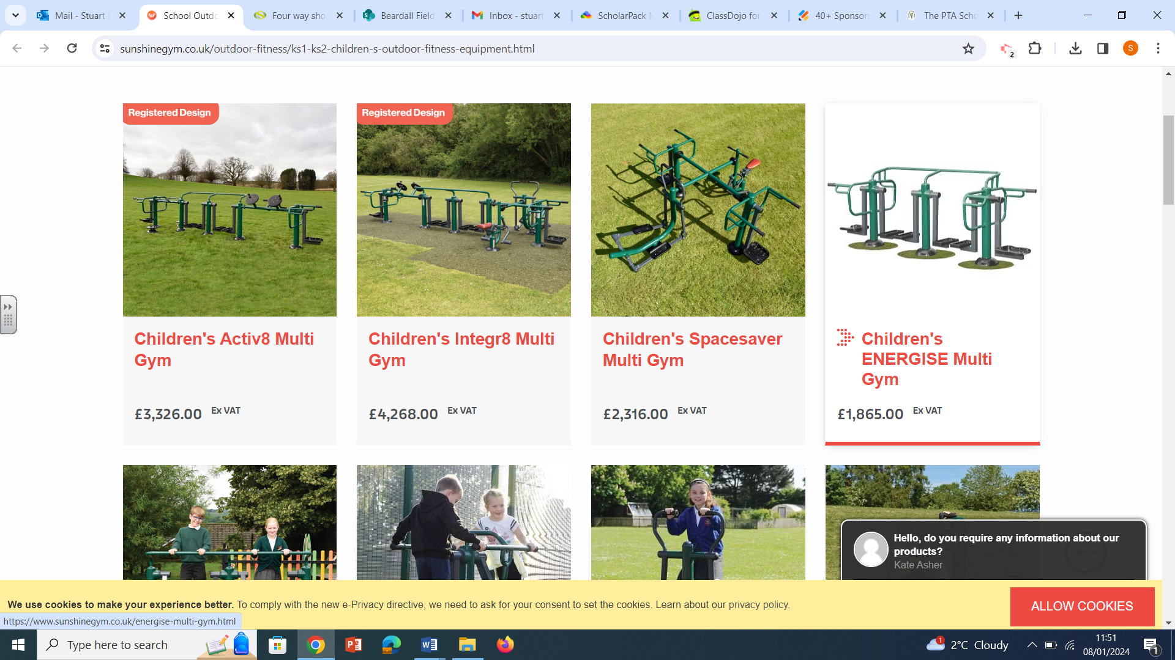
Child-friendly fitness equipment

PTA Sponsored Lands End to John O’Groats Run
Childs Name: Class:

Name | Fixed Amount | Amount per mile | Total
TOTAL | £ | £ | £

Supporting Learning At Home
There are several ways you can help your child with learning at home. Log onto any of the following sites we have subscribed to or pick up a book from The Reading Olympiad. If you have any questions about log in details, or wish for work to be set for your child, please contact your class teacher.
Mathematics Reading






Science Music



Whole Curriculum


